CSFV Joomla Hosting Platform Architecture
Author | Revision Number | Date
architect | 1.0 | June 25, 2012

CSFV Joomla Hosting Platform Architecture 1
System Design Specification 3
1. Introduction 3
1.1 Purpose 3
1.2 Glossary 3
2. Logical Architecture 4
2.1 User Interface 4
2.2 Business Services 4
2.3 Data Layer 4
3. Modular Architecture 4
4. Data Model 4
5. Process Architecture 4
5.1 Joomla basic setup 4
5.2 Joomla cluster setup 5
5.2.1 Fixing the HTML links 6
5.2.2 Session maintenance 7
5.3 Forum Functionality 8
5.4 Content Management System 9
5.5 Personalization 10
5.6 Leaderboard Test Component and Web Service 10
6. Security 12
6.1 Authentication and Authorization 12
6.2 Audit 12
6.3 Data Privacy 13
6.4 Data Integrity 13
7. Deployment and Development Concerns 13
7.1 Logical Deployment 13
7.1.1 Amazon specific information 15
7.2 Physical Deployment 15
7.2.1 User Metrics Requirements 15
7.2.2 Page Performance Requirements (assumed) 15
7.2.3 Operating System(s) 15
7.2.4 Software 15
7.2.5 Database 15
7.2.6 Browsers 15
7.2.7 Application Server 15
7.2.8 Frameworks/Tools 15
7.3 User Interface Implementation 15
7.4 Persistence 16
7.5 Concurrency and Transaction Management 16
7.6 Configuration 16
7.7 Logging 16
7.8 Internationalization 16
7.9 Validation 16
7.10 Exceptions 16

System Design Specification

Introduction

Purpose
Unreliable software places huge costs both on the military and the civilian economy. The current state of practice contains about one to five bugs per thousand lines of code. Formal program verification is the only way to be certain that a given piece of software is free of errors that could disrupt military operations in the field. Formal verification is currently done manually by specially-trained engineers. Consequently, formal verification has been too costly to apply beyond small, critical software components.

The Crowd Sourced Formal Verification (CSFV) program seeks to make formal program verification more cost-effective by reducing the skill set required for verification. The approach is to transform verification into a more accessible task by creating a game that reflects the code model, is intuitively understandable, and is fun to play. Completion of the game effectively helps the program verification tool complete the corresponding formal program verification proof.

The primary research challenge faced by CSFV is construction of automated game-level builders capable of transforming program verification models into compelling games. A particular game instance is a function of the program verification tool, the property to be verified and the program being verified. Each game instance is provided to the "crowd", either via the Web or through internal domain distribution. Game solutions are used to populate a database, then are mapped back into program annotations sufficient to allow the program verification tool to make progress toward verifying a specific program property.

This project, the CSFV Community Gaming website project will provide the web site infrastructure and integration of the games. This will be a web site that is available on the Internet, and also will be delivered in a form where the server and the games can be installed and used behind a firewall.

The technologies required for this project is not finalized yet. This contest is for evaluating Joomla 2.5.

Glossary
Term/Acronym | Definition
CMS | Content Management System
DNS | Domain Naming Service
TCP | Transmission Control Protocol
IP | Internet Protocol
PHP | A programming language (stands for Hypertext Preprocessor)
MVC | Model View Controller
HTML | Hyper Text Markup Language
XAMPP | A software stack consisting of Apache HTTP Server, MySQL, PHP and other software
HTTP | Hyper Text Transfer Protocol
DNS | Domain Naming Service
CSSTEM | An existing TopCoder project
EC2 | Elastic Compute Cloud (Amazon)
EBS | Elastic Block Storage (Amazon)
RDS | Relational Database Service (Amazon)

Logical Architecture
Note: This section will only deal with the software part of the intended solution. For the deployment details, refer to section 7.

This application is simply a Joomla application. Joomla uses PHP as it language. It uses MySQL backend. It can be deployed in a variety of web servers though we will use Apache Server.

We will use Joomla MVC based code for developing any custom functionality that needs to be offered by the application (see section 5.1 for more details).

User Interface
We will be using the user interface already offered by Joomla application and its components.
In case of custom development, we will use HTML templates as the view part of the MVC methodology.
On the client side, we will use MooTools as the JavaScript framework for Joomla. (This is the default option)

Business Services
In case of MVC usage, the controller class (extending from JController) will act as a web controller and will also contain the business logic to perform validations, call model method(s) and optionally bind to a view.

Data Layer
In case of MVC usage, the model class will extend from JModel. This model class will encapsulate all access to the database. The data access will be done using the JDatabase class.

Modular Architecture
There are no modules defined for this architecture. There are just two assemblies.
The first assembly will setup a basic cluster on a local machine. It will also provide the other demonstrations like the forum and test leaderboard component.
The second assembly will perform the deployment on actual Amazon EC2 instances.

Data Model
The data model will consist of Plain Old PHP Objects (POPO) classes. The objects of these classes will typically be returned by model methods.
In this contest, we have a test class called LeaderboardItem which encapsulates the {player, game, score} tuple. This will be returned by the ModelLeaderboard (which is the model for the MVC) methods.

Process Architecture

Joomla basic setup
In this section, I’ll describe the basic setup that we will perform for Joomla. It will discuss a single server setup.

Joomla will run inside the XAMPP 1.7.7 for Linux. This is a bundle of software that we will use for Joomla. We will use the following software from XAMPP:
- Apache HTTP Server 2.2.21 – The web server
- MySQL 5.5.16 – The database backend
- PHP 5.3.8 – The PHP runtime to run/modify Joomla

First XAMPP must be installed. See here for the steps. Assume that the installation folder is called <xampp-root>.

XAMPP must then be started and then tested. In case, port 80 is not opened, the Apache Server should listen to some other port. This can be changed by changing Listen 80 to Listen <some_open_port> in <xampp-root>/apache/conf/httpd.conf

After this we will download Joomla 2.5 zipped distributable and extract its contents to the <xampp-root>/htdocs/joomla25/ folder. Note that this folder will have to be created, it does not exist. This location is henceforth called <joomla-root>

Once this is done, we can simply visit http://localhost:<port>/joomla25/ and proceed with the installation wizard. The installation is fairly simple. Once the installation is complete, the same link above will point to the Joomla home page. The administration link can be accessed at http://localhost:<port>/joomla25/administrator/index.php

The entire process is described in great detail here.

Joomla cluster setup
In this section, I’ll describe a cluster setup for Joomla with the help of an example.

For the example we are assuming one load balancing server and 2 servers running separate installations of Joomla. All servers are running Apache HTTP server. We will assume the following addresses:
- Load balancing server: 127.0.0.1:6583
- Server 1: 127.0.0.1:7701
- Server 1: 127.0.0.1:7702

The client will only access the load balancer machine. It does not know of the existence of the individual Joomla machines. In fact these machines will be in an internal network and will not be accessible from the client i.e. if client enters 127.0.0.1:7701 or 127.0.0.1:7702, they will get an “unknown host” error.

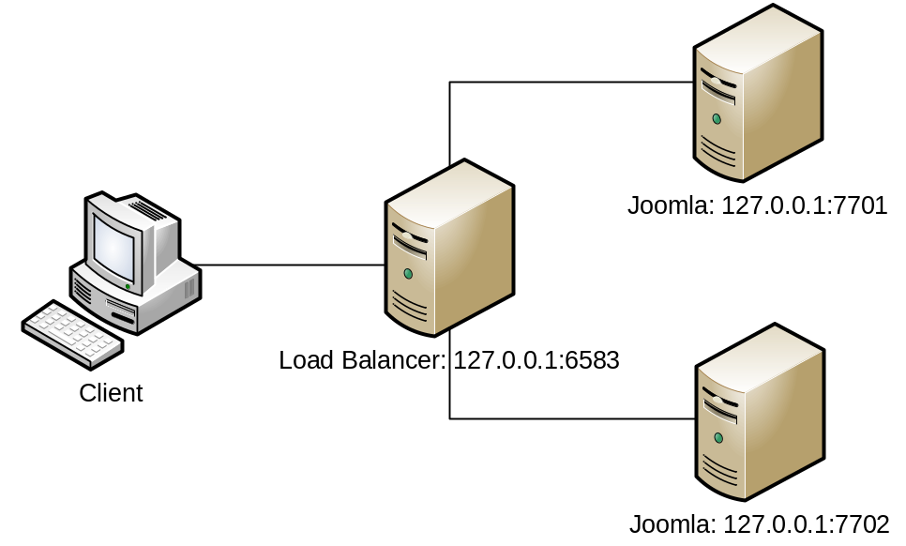

IMPORTANT: Note that the above is just an example. The actual server layout will be different (see section 7.1) Please also note that it uses local addresses so that this setup can be (and has been) tested on a local environment.

This kind of a setup is called a reverse proxy. We will use Apache Server mod_proxy module for the proxy setup and mod_proxy_balancer module for the load balancer setup.

For this we will first need to load the mod_proxy, mod_proxy_balancer and mod_proxy_http modules in the Load Balancer’s Apache Server httpd.conf.

LoadModule proxy_module modules/mod_proxy.so
LoadModule proxy_balancer_module modules/mod_proxy_balancer.so
LoadModule proxy_http_module modules/mod_proxy_http.so

The configuration for the balancer will be the following:
<Proxy balancer://mycluster/>
BalancerMember http://127.0.0.1:7701 loadfactor=1
BalancerMember http://127.0.0.1:7702 loadfactor=1
</Proxy>

The name of the balancer is balancer://mycluster/. The load between the target machines will be shared in the ratio 1:1 i.e. every alternate request will be handled by one target machine. There are other sharing algorithms but this is one suffices for now.

The configuration for the proxy will be as follows:
ProxyPass / balancer://mycluster/
ProxyPassReverse / balancer://mycluster/

Here, the first line states that all incoming requests to this server should be routed to one of the balancer servers. So a request to http://127.0.0.1:6583/abcd/xyz will be mapped to http://127.0.0.1:7701/abcd/xyz or http://127.0.0.1:7702/abcd/xyz based on the load balancer state.

The second line states that if the response header contains URLs which are relative to the target machine then they should be converted back to load balancer based URL. So for example in case of an HTTP redirect we can have the following header:
HTTP/1.1 302 Found
Location: http://127.0.0.1:7701/abcd/xyz/
The ProxyPassReverse will convert the above to
HTTP/1.1 302 Found
Location: http://127.0.0.1:6583/abcd/xyz/

Fixing the HTML links
The above configuration will effectively convert request and response headers URLs from the load balancer to the target machines (and vice versa). But it will not be able to convert HTML links in the served html.
So the following links
- <a href="somefile.html">
- <a href="/somefile.html">
- <a href="http://127.0.0.1:7701/somefile.html">
will all resolved relative to the target machine. This will result in “host not found” errors because the client browser does not know of the existence of the target machines.

For this will use the Apache mod_proxy_html module to convert the links to the proper URL.
The module needs to be declared and enabled. This is done as follows:
LoadFile modules/mod_proxy_html/libxml2.so
LoadModule proxy_html_module modules/mod_proxy_html/mod_proxy_html.so
LoadModule xml2enc_module modules/mod_proxy_html/mod_xml2enc.so

xml2EncDefault UTF-8
ProxyHTMLEnable On

#Uncomment the following for debugging
#ProxyHTMLLogVerbose On
#LogLevel Info

The module then needs to be told about the html attributes that it should attempt to convert. This is done as follows
ProxyHTMLLinks a href
ProxyHTMLLinks link href
ProxyHTMLLinks img src
ProxyHTMLLinks form action
ProxyHTMLLinks script src

The module then needs to be told the mapping of the source url format to the target url format
ProxyHTMLURLMap http://127.0.0.1:7701/ /
ProxyHTMLURLMap http://127.0.0.1:7702/ /
ProxyHTMLURLMap http://127.0.0.1:6583/ /
ProxyHTMLURLMap / http://127.0.0.1:6583/
Here the first 3 lines convert any absolute URL in the html into a relative url. The last line is the most important and it will convert any relative urls to absolute URL where the url is of the load balancer.
The end result is that in the response HTML, all links will be absolute URLs pointing to the load balancer.

Designer has tested the above setup to be correct (albeit on Windows). The httpd.conf for the load balancer is provided in test_files folder.

Session maintenance
Joomla uses the database to store the session data. So if two Joomla installations are sharing the same database, then effectively they are sharing the same sessions if for the same user, they generate the same session_id.

However by default each application generates a different session_id. This is because the session_id generation is based on the application secret key. We can observe this in the JApplication (<xampp-root>/htdocs/libraries/joomla/application/application.php) constructor which calls:
$this->_createSession(self::getHash($config['session_name']));
The getHash method has this implementation
public static function getHash($seed)
{
return md5(JFactory::getConfig()->get('secret') . $seed);
}

The application secret key will by default be different for each installation. It can be found in the JConfig class (<joomla-root>/configuration.php). It is the $secret variable. This $secret key must be the same for each installation.

Once this is done, we can login in one Joomla server (say 127.0.0.1:7701) and can then refresh the home page in the other Joomla server (127.0.0.1:7702) and we can observe that the user is logged-in in the second server as well. (This has been tested by architect)

Forum Functionality
We will use Kunena for the forum functionality. Kunena is a forum extension designed specifically for Joomla and hence builds on top of the Joomla framework. It integrates properly with the Joomla user authentication and authorization mechanism, MVC framework, other Joomla extensions etc. It uses the Joomla database as its backend as well.

The Kunena 1.7.2 distribution can be downloaded from here. Once downloaded, we can go to the Joomla admin site → Extensions → Extension Manager and then upload and install the downloaded package file (see screenshot below)

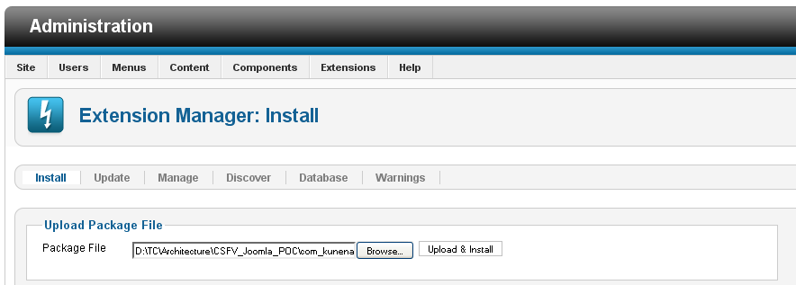

Once the installation is complete, the Kunena control panel can be accessed at <joomla_installation_dir>/administrator/index.php?option=com_kunena. There are a wealth of configuraton options as described here.

After this we can go to the Menu Manager and add the Kunena menu item to the main menu. Once this is done we can then click the Forum menu item, which shows us the forum. (see below). As you can notice, the logged in user is automatically logged into the forum as well.

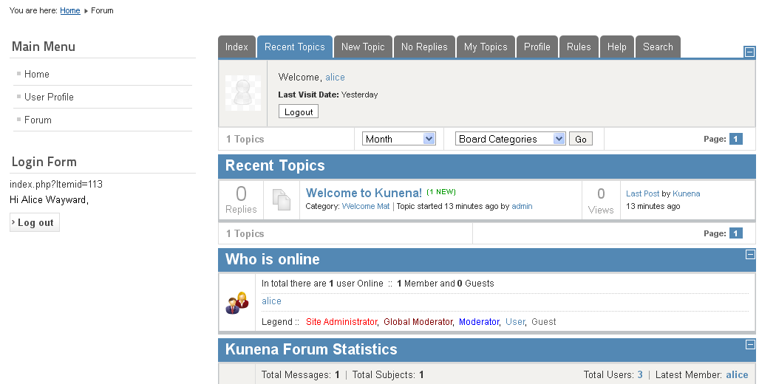

A fairly limited Blogs functionality is required. We only need the ability to show a page with user posts in descending order of time. The Joomla home page already does this for us, and we can just include this page wherever required.
We also need an ability to add comments to user posts. This can be done using the JComment extension.
We also need the ability to add tags to user posts. This can be done using the TorTags extension.

Content Management System
Joomla provides many ways of content management from the admin interface:

Articles can be managed (added/edited/published/unpublished/feature/archive etc) from the http://localhost:<port>/joomla25/administrator/index.php?option=com_content link.
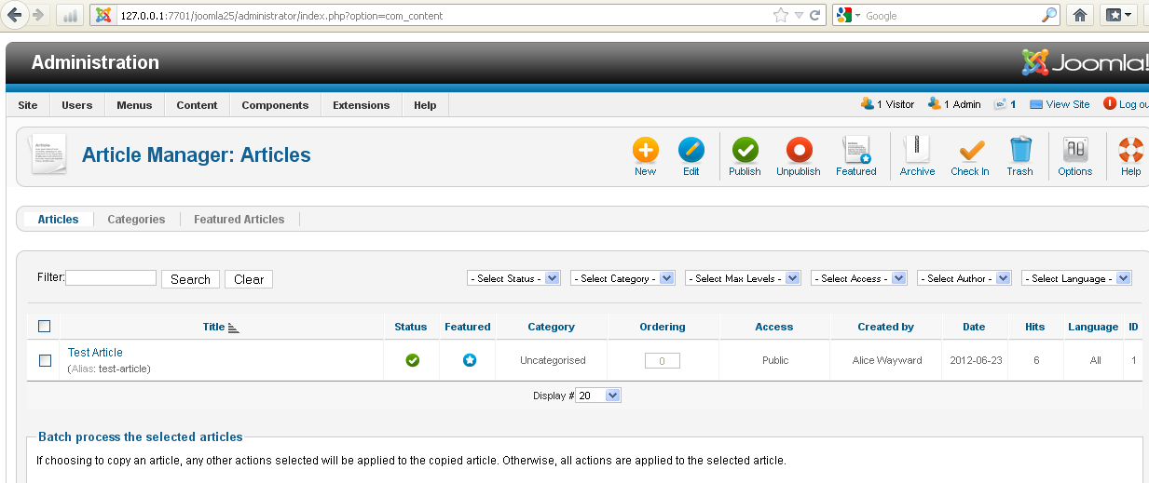

Media like images, documents, videos can be managed from the http://localhost:<port>/joomla25/administrator/index.php?option=com_content link.
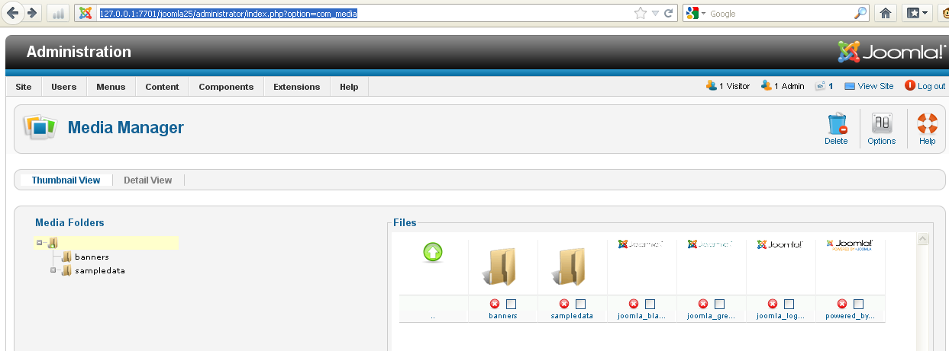

Similarly, style templates can be managed from the http://localhost:<port>/joomla25/administrator/index.php?option=com_templates link.

Personalization
For personalization, we need the user profile and user preferences features. The User Profile page already exists in Joomla. As of now, it allows to set a limited number of preferences like Name, UserName, Email, Password, Default WYSIWYG Editor, Time zone and Language. If more preferences are needed, they can be defined and added to this page.

Please note that users cannot change the layout of their page. However, note that administrator can change the layout of the pages somewhat. A Joomla page layout is defined by modules laid out at predefined positions. These positions can be changed. This is demonstrated on this page.

Leaderboard Test Component and Web Service
The component will be developed as a Joomla component. It will be called leaderboard. Components are placed in the <joomla-root>/component/com_<component_name> folder.

It will use Joomla MVC architecture. Please see the Leaderboard MVC Class Diagram.

The leaderboard.php is the entry point for the component. It is a plain PHP file (not a class as explained here). It will have the following implementation. Note that it does not end with php tag.

<?php

// No direct access to this file
defined('_JEXEC') or die('Restricted access');

// import joomla controller library
jimport('joomla.application.component.controller');

// Get an instance of the controller prefixed by Leaderboard
$controller = JController::getInstance(‘Leaderboard’);

// Perform the Request task
$controller->execute(JRequest::getCmd('task'));

// Redirect if set by the controller
$controller->redirect();

The LeaderboardController’s display will consist of the following logic:

//Get the default view for the controller
$view = $this->getView('view', 'html');

//Get the model for the controller and tell to view that it is the //default model for view (MVC indeed!)
$view->setModel($this->getModel('Leaderboard', 'Model'), true);

//Display the view
$view->display();

The LeaderboardController’s updateLeaderboard will return json for the ajax call. Please note that this method acts a web service as well. It can be accessed by http://<root-joomla-path>/index.php?option=com_helloworld&task=updateLeaderboard&format=json

// Get the model.
$model = $this->getModel('Leaderboard', 'Model');

// Get the data
$data = $model->getLeaderboard();

// Check for errors.
if ($model->getError()) {
//Write some helpful message to json
//It should be a json object with just one key called errorMessage
}

echo json_encode($data);

The leaderboard data will be stored in database. There will simply be table which holds 3 columns {player, game, score}. The ModelLeaderboard’s getLeaderboard simply gets all the LeaderboardItem records from the database.
We will also need to write a cron job which will update the leaderboard table with some sample data at a configurable interval. This is easy enough and is left to the assembler.

The LeaderboardViewLeaderboard’s display method will have the following logic:

// Call the getLeaderboard method of the default model
$data = $this->get('Leaderboard');

The views\helloworld\tmpl\default.php is the html template for the view. This is where the data will be bound to the html. It will also be where the AJAX request will be made from. The code for the template file is as follows:

<?php

// No direct access to this file
defined('_JEXEC') or die('Restricted access');
JHTML::_( 'behavior.mootools' );

$ajax = "
window.addEvent('domready', function() {
$('start_ajax').addEvent('click', function(e) {
e.stop();
var url = 'index.php?option=com_leaderboard&task=updateLeaderboard&format=json';
var x = new Request({
url: url,
method: 'post',
onSuccess: function(responseText){
//Write code here to update ajax_container
//with the retrieved results
}
}).send();
});
})
";

$doc = & JFactory::getDocument();
$doc->addScriptDeclaration( $ajax );

?>
<div>
<div><a id="start_ajax" href="#">Click here</a> to start Ajax request</div>
<div id="ajax_container">

</div>
</div>
The code constructs MooTools JavaScript for making AJAX call and adds the script declaration to the html document. The AJAX calls the web service defined above and will write the retrieved leaderboard array to the ajax_container HTML div.
We also need to make one change to the script above. The AJAX call should be timed ajax call instead on a button click. Here is an example that shows how to do so with MooTools.

NOTE of caution: Joomla has a very strange MVC structure. Especially the naming convention is very confusing. Here is a post which lists some issues that you might expect from an MVC but is not available in Joomla.
NOTE of caution 2: Joomla has rather poor and confusing documentation. Your best bet is placing echo statements to debug rather than depending on documentation. Also, make sure that you are not referring to any Joomla 1.5 documentation. Joomla 1.6 (mostly), 2.5, Platform 11+ are all fine.

Security

Authentication and Authorization
Authentication is provided in Joomla with the help of the mod_login module.
Authorization is provided in Joomla in the JUser class (libraries/joomla/user/user.php) authorize method.
User authorization can be set in the admin tool.

Audit
There are no auditing privacy issues.

Data Privacy
There are no data privacy issues.

Data Integrity
There are no data integrity issues.

Deployment and Development Concerns

Logical Deployment
The system architecture diagram is as follows:

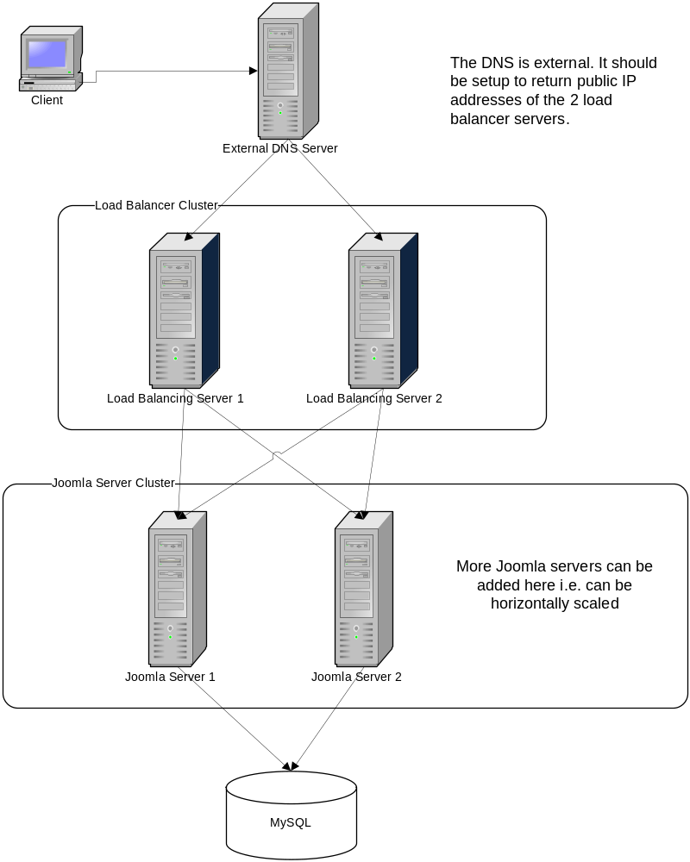
- The DNS server is external. It should be setup to return the public IP addresses of the 2 load balancer servers.
- The presence of 2 load balancer servers instead of just 1 will prevent the load balancing server from becoming a single point of failure.
- Each load balancer will act as a gateway to each of the Joomla servers. Initially, only 2 should be enough, although more can be added later.
- Each Joomla server must run the same codebase.
- Each load balancer server will run an Apache HTTP Server in load balancing mode.
- Each Joomla server will run the XAMPP for Linux stack along with the Joomla installation.
- There will be a single MySQL server which will serve all Joomla servers.

Amazon specific information
The strategy used in the CSSTEM setup is that there is a single EBS attached to one of the servers. This server then exposes an NFS to the other servers. Although this means that there is just one file system that all servers can access, the big drawback is that this NFS server becomes a single point of failure. If it fails, all other servers cannot access the file system. Therefore we will NOT use such a setup.

We will use therefore use one EBS for each of the servers. We can simply use a cron job which uses rsync to keep the server file systems up to date.

We should use Amazon RDS for MySQL to achieve scalability (although not redundancy) to the MySQL server setup.

Physical Deployment

User Metrics Requirements
- Not known but architecture is horizontally scalable to accommodate the requirements.

Page Performance Requirements (assumed)
- The application will be available 24x7. Up-time will be 99.5%.

Operating System(s)
- CentOS

Software
- PHP 5.3.8

Database
- MySQL 5.5.16

Browsers
- Latest versions of all browsers

Application Server
- Apache HTTP Server 2.2.21

Frameworks/Tools
- XAMPP 1.7.7 for Linux: http://www.apachefriends.org/en/xampp-linux.html
- PHP 5.3.8: (part of XAMPP)
- Joomla 2.5: http://www.joomla.org/download.html
- MooTools 1.4.5: (part of Joomla)
- Amazon EC2, EBS, RDS

User Interface Implementation
Joomla provides its own user interface. For custom development using MVC, the view will be HTML based templates.

Persistence
All persistence will take place with the use of JDatabase class provided by Joomla. The specific implementation that we will use is JDatabaseDriverMysql

Concurrency and Transaction Management
The JDatabase class provides the transactionStart, transactionCommit and transactionRollback methods which can be used for transactions if required.

Configuration
The JConfig (<joomla-root>/configuration.php) class is used for application configuration.

Logging
The application will perform automatic logging of errors, exceptions, warnings, debug messages using the JLog class. The concrete implementation of JLog must be configurable.

Internationalization
There are no internationalization requirements.

Validation
Business validation if required should be performed in the MVC Controller.

Exceptions
Joomla provides many exception classes which can be thrown like any exception. Please note that the JException and JError classes are now deprecated and must not be used.

